FH330-how to modify the Wi-Fi name and password
Product line: Wireless Model number:FH330
This document is suitable for the users that need to modify Wi-Fi name and password.
1. Input 192.168.0.1 in the address bar of the web browser, as bellow：
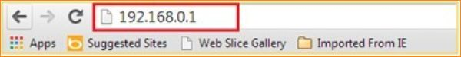
1.Change your Wi-Fi name and password by click Internet in the management page.
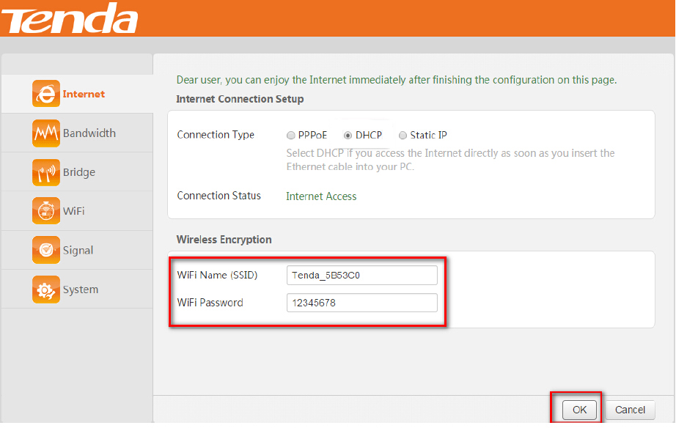
Notice：
1. We strongly recommend you change your Wi-Fi name when you change the password；
2. After modification, your wireless network will loss connection, you need scan and re-connect.

